**Using LCA to group students pathways throughout the course (weeks 2-13)**

LCA was performed on the dataset (N = 290) consisting of 12 categorical variables, one for each week of the course (week 2 – week 13), representing the cluster each student belonged to in the given week. Variables for weeks 5, 7, 9, 11 and 12 have 4 distinct values, as 4 clusters were detected for those weeks; variables for the other 6 weeks have 5 different values, matching the 5 identified clusters.

To avoid running into local maximum, the model building process was repeated 50 times (using different initial parameter values) for each considered number of classes (3-6). Table 1 shows evaluation metrics. The obtained metric values are inconclusive regarding the best number of classes. The solution with nclass=5 was chosen as the one that was the most interpretable

Table 1. Evaluation metrics for different number of classes

====== ======== ======== ========= =========

nclass AIC BIC LogLike ChiSquare

====== ======== ======== ========= =========

3 8644.280 9125.035 -4191.140 70374479

4 8574.429 9216.658 -4112.215 41807103

5 8549.295 9352.999 -4055.647 22750311

6 8533.964 9499.143 -4003.982 39945034

====== ======== ======== ========= =========

**Results for the solution with 5 classes**

**Interpretation of the classes**

The most probable path for students in **Class 1** (29.3%):

W2: C5(0.34)| C4(0.32) -> W3: C4(0.41)|C1(0.31)|C5(0.24) -> W4: C3(0.47)|C5(0.24)|C2(0.24) -> W5: C2(0.55)|C4(0.34) -> W6: C1(0.47)|C2(0.31) -> W7: C2(0.56)|C4(0.29) -> W8: C1(0.41)|C3(0.39) -> W9: C4(0.58)|C2(0.39) -> W10: C1(0.66)|C4(0.24) -> W11: C2(0.83) -> W12: C4(0.51)|C3(0.43) -> W13: C1(0.52)|C4(0.21)

The most probable path for students in **Class 2** (19.4%):

W2: C1(0.38)|C5(0.33) -> W3: C1(0.55)|C4(0.27) -> W4: C4(0.34)|C2(0.31) -> W5: C4(0.67)|C2(0.24) -> W6: C2(0.54) -> W7: C4(0.55)|C3(0.25)|C2(0.2) -> W8: C4(0.59)|C3(0.2) -> W9: C2(0.77) -> W10: C2(0.65)|C4(0.24) -> W11: C3(0.47)|C2(0.35) -> W12: C2(0.57)|C4(0.33) -> W13: C1(0.66)

The most probable path for students in **Class 3** (18.1%):

W2: C5(0.47)|C2(0.24) ->W3: C5(0.34)|C4(0.3)|C2(0.2) -> W4: C2(0.61)|C1(0.25) -> W5: C2(0.42)|C1(0.36)|C3(0.2) -> W6: C1(0.32)|C2(0.3)|C4(0.22) -> W7: C2(0.38)|C3(0.31)|C1(0.27) -> W8: C5(0.35)|C1(0.26)|C3(0.25) -> W9: C1(0.45)|C2(0.34)|C4(0.21) -> W10: C4(0.44)|C1(0.42) -> W11: C2(0.51)|C1(0.33) -> W12: C4(0.45)|C3(0.23)|C2(0.21) -> W13: C1(0.43)|C3(0.27)

The most probable path for students in **Class 4** (17.2%):

W2: C2(0.46)|C4(0.43) -> W3: C5(0.72) -> W4: C2(0.63) -> W5: C1(0.63)|C2(0.22) -> W6: C2(0.42)|C1(0.25)|C4(0.2) -> W7: C1(0.72)|C3(0.2) -> W8: C5(0.57)|C2(0.28) -> W9: C3(0.53)|C1(0.33) -> W10: C3(0.66) -> W11: C1(0.72)|C2(0.2) -> W12: C1(0.63)|C4(0.22) -> W13: C3(0.25)|C2(0.24)|C1(0.22)

The most probable path for students in **Class 5** (15.9%):

W2: C3(0.49)|C2(0.3) -> W3: C2(0.79) -> W4: C1(0.59)|C2(0.41) -> W5: C1(0.58)|C3(0.34) -> W6: C4(0.30)|C1(0.24)|C3(0.24) -> W7: C1(0.72) -> W8: C2(0.44)|C5(0.39) -> W9: C3(0.79) -> W10: C3(0.46)|C4(0.29) -> W11: C1(0.62)|C4(0.24) -> W12: C1(0.8) -> W13: C2(0.32)|C1(0.24)|C4(0.24)

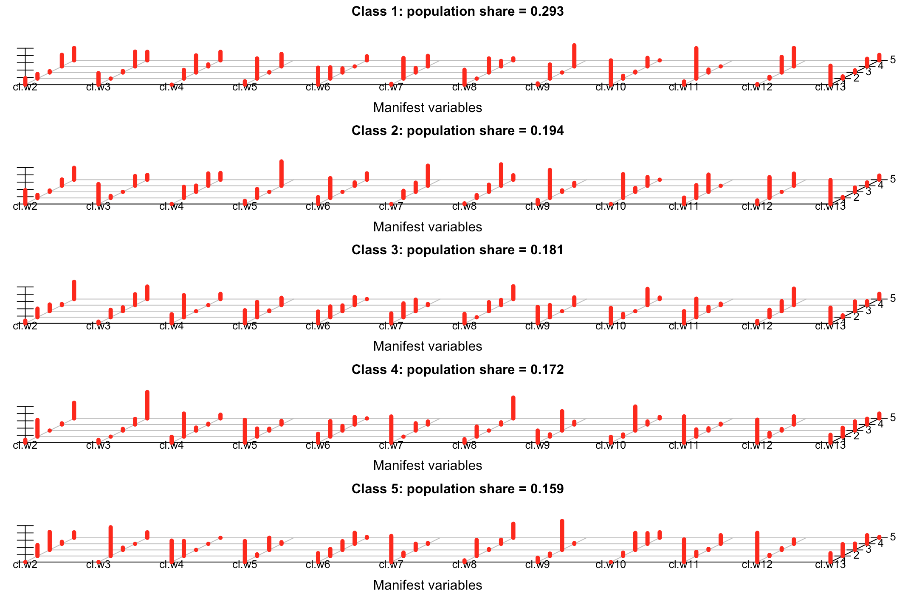

**INTERPRETATION BASED ON CLUSTERS IDENTIFIED WITH ABELARDO**

|  |  |  |  |  |  |
| --- | --- | --- | --- | --- | --- |
|  | **CLASS 1 (29.3%)** | **CLASS 2 (19.4%)** | **CLASS 3 (18.1%)** | **CLASS 4 (17.2%)** | **CLASS 5 (15.9%)** |
| **WEEK 2** | C1|B1 | A|C1 | C1|D | D|B1 | E|D |
| **WEEK 3** | B1|C1|A | C1|B1 | A|B1|E | A | E |
| **WEEK 4** | B1|A|C1 | B2|C1 | C1|E | C1 | E|C1 |
| **WEEK 5** | B1|A | A|B1 | B1|D|E | D|B1 | D|E |
| **WEEK 6** | C2|C1 | C1 | C2|C1|D | C1|C2|D | D|C2|A |
| **WEEK 7** | B1|D | D|C1|B1 | B1|C1|E | E|C1 | E |
| **WEEK 8** | B1|C1 | A|C1 | B2|B1|C1 | B2|E | E|B2 |
| **WEEK 9** | B1|D | D | B2|D|B1 | E|B2 | E |
| **WEEK 10** | B2|E | A|E | E|B2 | D | D|E |
| **WEEK 11** | C1 | B1|C1 | C1|E | E|C1 | E|F |
| **WEEK 12** | B1|F | E|B1 | B1|F|E | B2|B1 | B2 |
| **WEEK 13** | A|C2 | A | A|D | D|C1|A | C1|A|C2 |

**The abbreviations used in the class-comparisons table**:

* A – disengaged
* B1, B2 – gaming/guessing assessment
* C1, C2 – low engaged, assessment driven
* D (Eff) – engaged and effective/efficient
* E (Top) - engage frequently in all kinds of activities
* F - cheaters

**Comparison of LCA classes based on the students’ final exam score**

Since data about students’ final exam score are not normally distributed, non-parametric tests were performed: Kruskal-Wallis test followed by Mann-Whitney U test for pair-wise comparison.

Descriptive statistics

===== === ====== ===== ====

class N median Q1 Q3

===== === ====== ===== ====

1 85 14.0 11.00 19.0

2 58 15.5 11.25 22.0

3 51 21.0 15.00 27.5

4 51 26.0 17.00 34.0

5 45 18.0 14.00 26.0

===== === ====== ===== ====

Pairwise comparisons with the FDR correction

=== === === ======= ======== =========== ===========

\ c1 c2 Z p effect.size significant

=== === === ======= ======== =========== ===========

3 1 4 -5.6740 0.000000 0.4865 YES

2 1 3 -4.6604 0.000002 0.3996 YES

6 2 4 -4.1916 0.000018 0.4015 YES

4 1 5 -3.0786 0.001903 0.2700 YES

5 2 3 -2.7244 0.006139 0.2610 YES

10 4 5 2.5803 0.009490 0.2634 YES

8 3 4 -1.9766 0.047970 0.1957 NO

7 2 5 -1.6980 0.089874 0.1673 NO

1 1 2 -1.6614 0.096927 0.1389 NO

9 3 5 1.0146 0.312694 0.1036 NO

=== === === ======= ======== =========== ===========

To conclude, significant difference with respect to the final exam score are detected between the following pairs of classes: 1 – 3, 1 – 4, 1 – 5, 2 – 3, 2 – 4, 4 – 5.

Raw output obtained from poLCA

Conditional item response (column) probabilities, by outcome variable, for each class (row)

$cl.w2

Pr(1) Pr(2) Pr(3) Pr(4) Pr(5)

class 1: 0.1773 0.1268 0.0355 0.3201 0.3403

class 2: 0.3796 0.0844 0.0367 0.1729 0.3264

class 3: 0.0746 0.2368 0.1838 0.0304 0.4744

class 4: 0.0787 0.4588 0.0000 0.0315 0.4310

class 5: 0.0000 0.3008 0.4945 0.0552 0.1496

$cl.w3

Pr(1) Pr(2) Pr(3) Pr(4) Pr(5)

class 1: 0.3145 0.0000 0.0418 0.4067 0.2370

class 2: 0.5466 0.0541 0.0000 0.2668 0.1325

class 3: 0.0469 0.2054 0.1052 0.2993 0.3432

class 4: 0.0761 0.0000 0.0459 0.1531 0.7249

class 5: 0.0000 0.7882 0.0618 0.0000 0.1500

$cl.w4

Pr(1) Pr(2) Pr(3) Pr(4) Pr(5)

class 1: 0.0000 0.2379 0.4704 0.0553 0.2364

class 2: 0.0000 0.3057 0.1711 0.3389 0.1844

class 3: 0.2492 0.6080 0.0000 0.0000 0.1428

class 4: 0.1620 0.6330 0.0816 0.0204 0.1030

class 5: 0.5878 0.4122 0.0000 0.0000 0.0000

$cl.w5

Pr(1) Pr(2) Pr(3) Pr(4)

class 1: 0.0929 0.5525 0.0114 0.3432

class 2: 0.0863 0.2450 0.0000 0.6688

class 3: 0.3580 0.4214 0.0198 0.2008

class 4: 0.6290 0.2219 0.0516 0.0974

class 5: 0.5761 0.0441 0.3350 0.0447

$cl.w6

Pr(1) Pr(2) Pr(3) Pr(4) Pr(5)

class 1: 0.4659 0.3085 0.1127 0.0000 0.1129

class 2: 0.1896 0.5427 0.0000 0.0927 0.1750

class 3: 0.3232 0.2958 0.1578 0.2232 0.0000

class 4: 0.2460 0.4246 0.1249 0.2044 0.0000

class 5: 0.2445 0.1911 0.2387 0.3041 0.0217

$cl.w7

Pr(1) Pr(2) Pr(3) Pr(4)

class 1: 0.0220 0.5647 0.1227 0.2906

class 2: 0.0000 0.1957 0.2524 0.5519

class 3: 0.2709 0.3814 0.3170 0.0307

class 4: 0.7194 0.0000 0.1996 0.0809

class 5: 0.7160 0.0921 0.1698 0.0221

$cl.w8

Pr(1) Pr(2) Pr(3) Pr(4) Pr(5)

class 1: 0.4080 0.0000 0.3867 0.1496 0.0557

class 2: 0.0177 0.0771 0.1955 0.5881 0.1215

class 3: 0.2590 0.0000 0.2473 0.1415 0.3522

class 4: 0.0953 0.2751 0.0000 0.0574 0.5722

class 5: 0.0451 0.4389 0.0196 0.1103 0.3861

$cl.w9

Pr(1) Pr(2) Pr(3) Pr(4)

class 1: 0.0337 0.3861 0.0000 0.5802

class 2: 0.1108 0.7688 0.0404 0.0800

class 3: 0.4523 0.3351 0.0000 0.2127

class 4: 0.3329 0.0623 0.5303 0.0745

class 5: 0.1186 0.0649 0.7948 0.0217

$cl.w10

Pr(1) Pr(2) Pr(3) Pr(4) Pr(5)

class 1: 0.6651 0.0752 0.0245 0.2352 0.0000

class 2: 0.0000 0.6535 0.1066 0.2399 0.0000

class 3: 0.4222 0.0914 0.0000 0.4455 0.0409

class 4: 0.1603 0.0590 0.6595 0.0822 0.0390

class 5: 0.0000 0.0905 0.4658 0.2920 0.1517

$cl.w11

Pr(1) Pr(2) Pr(3) Pr(4)

class 1: 0.0863 0.8324 0.0813 0.0000

class 2: 0.1752 0.3507 0.4740 0.0000

class 3: 0.3338 0.5113 0.1147 0.0402

class 4: 0.7220 0.1971 0.0607 0.0202

class 5: 0.6216 0.1135 0.0280 0.2369

$cl.w12

Pr(1) Pr(2) Pr(3) Pr(4)

class 1: 0.0149 0.0493 0.4289 0.5069

class 2: 0.0972 0.5687 0.0000 0.3341

class 3: 0.0673 0.2063 0.2739 0.4524

class 4: 0.6330 0.1026 0.0408 0.2236

class 5: 0.8022 0.0300 0.0462 0.1216

$cl.w13

Pr(1) Pr(2) Pr(3) Pr(4) Pr(5)

class 1: 0.5204 0.0596 0.0597 0.2102 0.1501

class 2: 0.6556 0.0206 0.1180 0.0920 0.1137

class 3: 0.4300 0.0522 0.2673 0.1072 0.1433

class 4: 0.2165 0.2435 0.2501 0.1570 0.1329

class 5: 0.2429 0.3249 0.1738 0.2359 0.0224

Estimated class population shares

0.2932 0.1944 0.1815 0.1721 0.1588

Predicted class memberships (by modal posterior prob.)

0.2931 0.2 0.1759 0.1759 0.1552

=========================================================

Fit for 5 latent classes:

=========================================================

number of observations: 290

number of fully observed cases: 239

number of estimated parameters: 219

residual degrees of freedom: 71

maximum log-likelihood: -4057.031

AIC(5): 8552.062

BIC(5): 9355.766

G^2(5): 4282.235 (Likelihood ratio/deviance statistic)

X^2(5): 64779570 (Chi-square goodness of fit)